**Raspberry Pi GPIO Sensing: Motion Detection**

In previous tutorials, we outlined the basics behind physical computing and the Raspberry Pi by activating LEDs and scripts using a simple one button circuit. If you haven’t read the previous tutorials please do so, as they include a few points (such as basic Python programming and Board/BCM GPIO numbering) that will be skipped in this tutorial.

In this tutorial, we’ll expand on previous lessons by transplanting a button with a PIR sensor (to sense motion). This tutorial will outline how to assemble the circuit with a PIR sensor, and devise a simple script to print a message when the sensor detects movement. In the next tutorial we’ll add a buzzer and LEDs to our sensing circuit to raise an alarm when an intruder is detected!

**PIR Sensors**

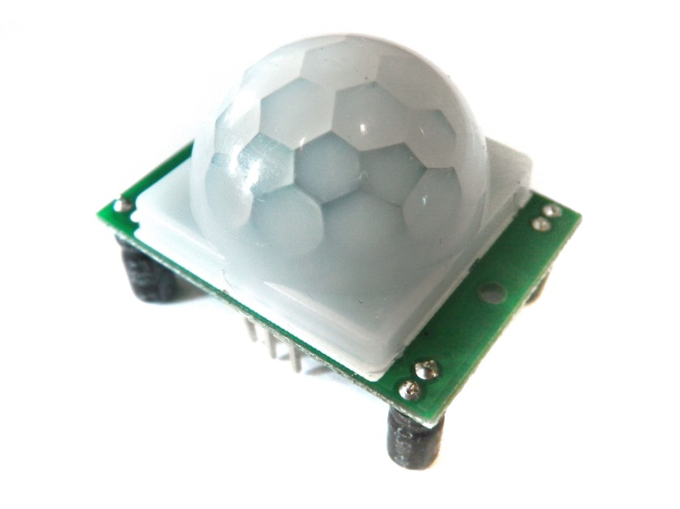

PIR sensors, often referred to as, "Passive Infrared" or "IR motion" sensors, enable you to sense motion. Everything emits a small amount of infrared radiation, and the hotter something is, the more radiation is emitted. PIR sensors are able to detect a change in IR levels of their detection zone (e.g. when a human enters a room) and hence sense motion.

The PIR sensors we’ll be using in this tutorial have three pins: ground, digital out and 3-5VDC in. At idle, when no motion has been detected, the digital out will remain low, however when motion is detected, the digital out will pulse high (3.3V) and we’ll use our Raspberry Pi to sense this! The PIR sensors we’ll be using in this tutorial have a range of approximately 7 meters, and a 110° x 70° detection range, so it’s great for monitoring a door or the corner of a room.

For this exercise you will require:

* Breadboard
* 6 x Male to Female Jumper Wires
* PIR Sensor

**Assemble the Circuit**

**Note**. We could hook the PIR directly to the Pi’s GPIO pins (and it would work well!) however, as we’re going to add extra features later, we’ll construct it on a breadboard.

1. Plug three of your male to female jumper wires into the three pins on the PIR sensor. The three pins are labelled as the following: Red; PIR-VCC (3-5VDC in), Brown; PIR-OUT (digital out) and Black; PIR-GND (ground).

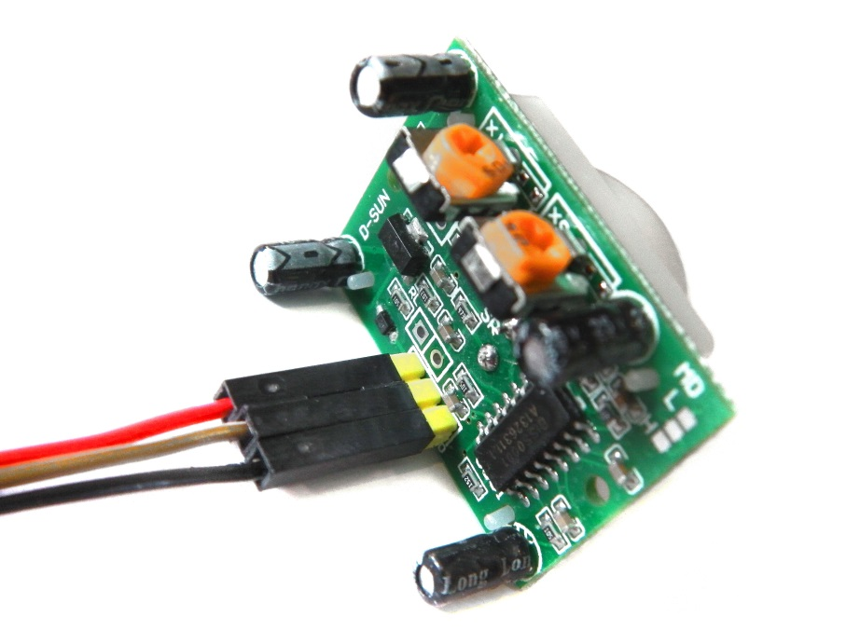

2. Plug PIR-VCC into the positive rail of your breadboard, plug PIR-GND into your negative rail, and plug PIR-OUT into any other blank rail.

3. Use a black jumper wire to connect GPIO GND [Pin 6] on the Pi to the negative rail of your breadboard. This is the same rail that we’ve added out PIR-GND wire.

4. Use a red jumper wire to connect GPIO 5V [Pin 2] on the Pi to the positive rail of your breadboard. This is the same rail that we’ve added our PIR-VCC and will power our PIR sensor.

5. We’ll be using GPIO 7 [Pin 26] as an input to sense when our PIR detects motion. Therefore the final step is to connect GPIO 7 [Pin 26] to the same rail as our PIR-OUT.

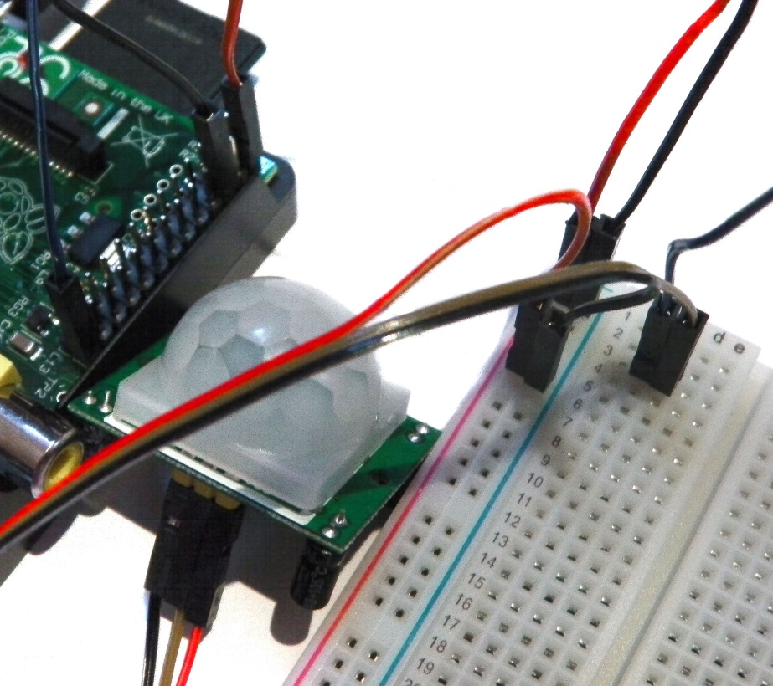

**Sensing with Python**

Now that we’ve hooked our PIR up to our Pi, we need to program a Python script to register when the PIR senses movement!

In our switch tutorial, we had to tie our input high and then have our Python programme define the difference between whether the input was high or low. The PIR on the other hand will always output low (0V) unless movement is detected, in which case it will output high (3.3V). We can therefore simply set our PIR-OUT GPIO pin as an input, and use Python to detect any voltage change.

First, import the Python GPIO library, import our time library (so we make our Pi wait between steps) and set our GPIO pin numbering.

**import RPi.GPIO as GPIO**

**import time**

**GPIO.setmode(GPIO.BCM)**

Next, we need to give our input pin a name, so that we can refer to it later in our Python code. Naming it “PIR_PIN” will enable us to read if the PIR is outputting a signal (e.g. movement has been detected). You can name a pin variable almost anything, so try playing around to see what you can get away with.

**PIR_PIN = 7**

We then need to define our GPIO pin that we just named PIR_PIN as an input.

**GPIO.setup(PIR_PIN, GPIO.IN)**

The next step is to add some cool text so that we know our PIR, Pi and Python programme are ready to detect movement. You can leave this out, or change it to anything you want! The following will print two lines of text with a two second gap between them.

**print “PIR Module Test (CTRL+C to exit)”**

**time.sleep(2)**

**print “Ready”**

To check the input status of PIR_PI we’re going to use a True statement running on an infinite loop.

**while True:**

**if GPIO.input(PIR_PIN):**

**print “Motion Detected!”**

**time.sleep(1)**

The code will then continuously check the PIR_PIN input, and will print a line of text if the input goes high. The time limit between each loop means that you should only have one output when movement is detected, as the PIR_PIN will switch low once the movement has stabilised.

That’s it! We can wrap our programme in a short piece of clean-up code to ensure that it exits cleanly. This isn’t compulsory, but it’s good practice.

**import RPi.GPIO as GPIO**

**import time**

**GPIO.setmode(GPIO.BCM)**

**PIR_PIN = 7**

**GPIO.setup(PIR_PIN, GPIO.IN)**

**try:**

**print “PIR Module Test (CTRL+C to exit)”**

**time.sleep(2)**

**print “Ready”**

**while True:**

**if GPIO.input(PIR_PIN):**

**print “Motion Detected!”**

**time.sleep(1)**

**except KeyboardInterrupt:**

**print “ Quit”**

**GPIO.cleanup()**

That’s it, a very simple method of connecting and coding a low cost movement sensor with the Raspberry Pi. Next time we’ll hook up a buzzer, some LED’s and a magnetic door lock (if I can get hold of one!) and start devising a low cost RPi based security system!

**Troubleshooting**

If you message just keep looping and looping you might have your PIR’s sensitivity set too high. Most PIRs have potentiometers on board which can adjust this. Clockwise increases sensitivity. As always, all parts featured in this article are available from the ModMyPi Shop, and the code and tutorial are also available online!

